Project Report

**BRIGHT CONSULTING IDEAS**

1. **Introduction**
   1. Overview

Bright IDEA saw the lack of special education resource across our country, leading to children not being able to reach their full academic potential. We provide quality professional development training and guidance to educators who need to learn how to advocate for their students no matter their abilities.

* 1. Purpose

Bright idea’s Consulting purpose are professionals apply practical, real-world experience to help you create impactful innovation programs. Services cover:

* Establishing and scaling innovation teams and programs
* Driving cultural change through a people-powered innovation approach
* Justifying program value through budgeting, financial impact tracking and more.

1. **Problem Definition & Design Thinking**
   1. Empathy Map

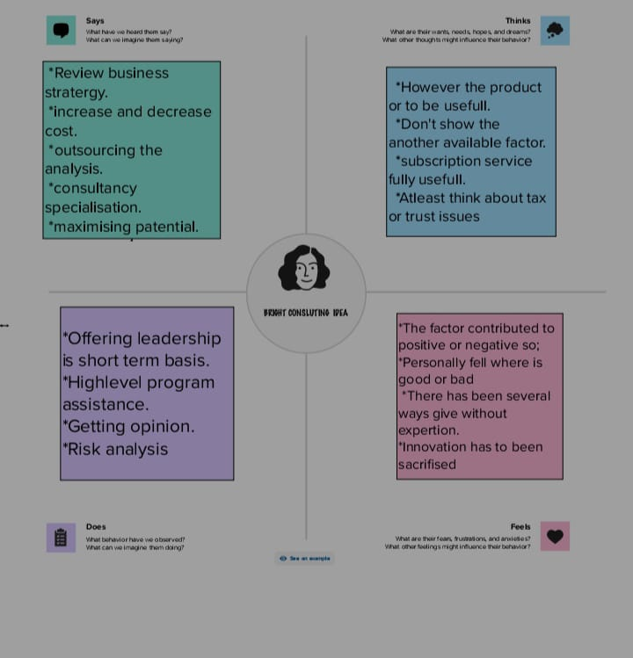

* 1. 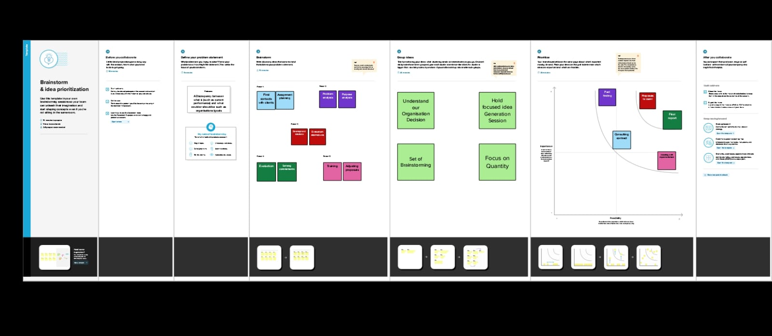Ideation & Brainstorming Map

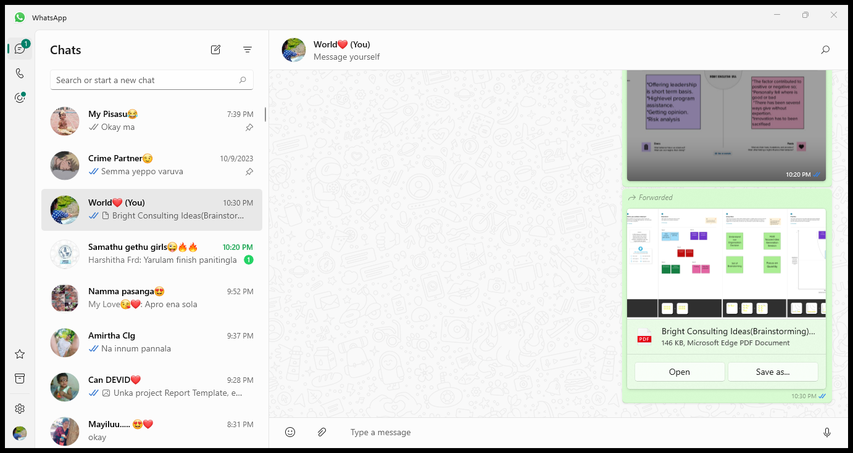**3.RESULT**

 

**4.ADVANTAGES & DISADVANTAGES**

4.1 ADVANTAGES:

* The opportunity to work with a wide variety of clients and industries, which can help you gain a broad range of experience & knowledge.
* High earning potential & good career opportunities.
  1. DISADVANTAGES:
* The pressure to delivery results for clients & meet tight deadlines.
* Constant travel & being away from family & friends.

**5.APPLICATIONS**





**6.CONCLUTIONS**

It was wonderful and learning experience for us while working team on this project , finally the topic of bright consulting ideas we have explored so many new ideas .And thank you so much to give us opportunity to show our project.

**7.FUTURE SCOPE**

Bright Consulting Ideas is looking for a Technical Implementation Consultant to provide product training, technical expertise, recommendations, and hands-on configuration support. The role will also require ensuring proactive communication to clients and internal staff, ability to understand simple-to-complex business requirements and design a technical solution to meet those needs.

The scope of these services, while based on best practices developed over hundreds of engagements, varies across clients and incorporates offerings such as:

* Innovation Strategy and Management
* Program Planning and Development
* Initiative Planning, Management and Execution
* Community Engagement and Activation
* Workshop and Event Facilitation
* Culture Development and Change Management
* Social Collaborative Technologies and Adoption.

**8.APPENDIX**

